Name
Institution
Date
Supermarket Project

Introduction
Grocery stores were until the recent past the main shopping avenue for most residents of Abu Dhabi. Residents would move to groceries which were within their residential building to access good foodstuff. However, with the introduction of the baqala standards by the Capital Authority of Abu Dhabi, most grocery stores have since closed down.
A walk in the streets of Abu Dhabi will leave one with a picture of a once massive business venture now going down. One question that needs answers is whether these baqala rules and standards were necessary, what are the regulations and standards in issues and whether or not the residents and business people in Abu Dhabi welcome it. This project, therefore, attempts to examine the baqala standards, reaction, an effect in which the project has on the residents and business ventures, the problems that come with it as well as the solution to these problems (Mohammad, Sidaway 2012)
Baqala Mini-Store Standards
The Food Control Authority of Abu Dhabi came up with certain rules and standards to ensure food safety of foods retailed in groceries in Abu Dhabi. These safety standards are what is known as the baqala standards. The criteria for baqala standard covers various operational and safety requirements. The standards require that grocery stores upgrade and renovate their premises to include unified logo and color of the business premise together with exterior and interior designs. In that respect, the designs of the supermarkets will appear uniform regarding their appearance. A Baqala sign is mounted on the side wall and the baqala sticker placed on the sides of the sign. Over the entrance will be the required Baqala sign, three meters wide and a meter high, with the shop's name and number in small print underneath (Khanna, 2010)
The safety measure also requires that a smoke detector, four emergency lights, an exit light as well as a series of fire extinguishers strategically placed be part of the renovated store. These safety measures according to food safety authority of Abu Dhabi will not only change the once congested grocery stores into well- spaced convenience stores but also ensure the safety of employees and customers visiting those stores. The smoke detectors will enable the store owners to prevent losses as a result of frequent fires thereby reducing their cost of doing business. “The safety measures will further ensure that the business premises can handle large quantities of products as well as a large number of customers.” (Mohammad, Sidaway 2012)
The baqala standards will also ensure that the electricity system changes from a one phase system to a two-phase system supplying over 10000 watts of power. The change in electricity system is necessitated by the fact the rules requires the installation of fridges and other electrical appliances that consume a high an amount of power. The electrical appliance ensures that food is well stored and do not go bad thus preventing the selling of foodstuff that is not fit for human consumption. “An air conditioner which is also an essential requirement according to the new rules pushes up the need for a high power system.” (Sandhya, 2016)
The new rules finally require that the shop itself be 35 square-meter minimum. With these, a corridor of at least 85 centimeters is needed. The size is to ensure that well- arranged shelves can fit in it. Space must also have a ceiling board, floor tiles as well as doors. This contributes to the general physical appeal of the venture and the business premise. On the shelves, the foodstuff needs a proper arrangement and the price tag for each product be placed conspicuously on the shelves where customers can see (Khanna, 2010)
Effects of the Baqala standards on the business owners
The immediate effect of the baqala standards on the businesses in Abu Dhabi was that some groceries closed down. A quick check on the streets of Abu Dhabi indicates most of the once thriving grocery stores closed down. This is because baqala standards require a series of renovation and revamp of the existing stores to meet the standards. This renovation requires a large sum of money which a majority of the small grocery stores owner cannot afford. One such grocery store owners are Rashid Mulekkel Mohammed, who has owned Al Azar vegetable and foodstuff in Muroor road for 16 years. He laments on having spent Dh130000 loan to renovate its business. This shows that many groceries who could not afford such amount opted out of business (Sandhya, 2016)
On the other hand, big retail supermarkets have welcomed the idea and have expanded accordingly. The influx of big retail supermarkets such as Carrefour, 7 Emirates supermarkets LLC, Abar Al Afaq foodstuff est, and many more demonstrates this fact. “The groceries will get a makeover and become more customer-friendly as a result of the new regulation. The improved exteriors and interiors will have a marked impact on the satisfaction of customers," said Sameer K. Mohamed, managing director of Jaleel Holdings. This response to an interview question by the managing director of Jaleel Holding clearly show the level at which they are happy with the new baqala standards. Mohammed further appreciates the idea of allowing the grocery stores to adjust to the new rules than just doing them spontaneously. With this, he is sure that the lifeline of most grocery stores is boosted as they will survive and operate conveniently (Khanna, 2010)
On his part, Dananjay Datar, the managing director of Al Adi Trading one of the leading chains retain stores in Abu Dhabi echoes the sentiments of Mohammed and goes further to explain the extent to which consumer will benefit from the shopping experience. He praises the standardization of grocery stores and views it as a positive step in the growth of Dubai as a shopping center. As a remark, he recognizes that it is the time for grocery stores to take advantage of the capital growth in Dubai through growth and move forward. In his view, groceries should never view this standardization as an expense but rather an investment for better growth in the long run as it will result in more customers and higher sales.
Based on the views of various groceries owners and business investors in Abu Dhabi, one can conclude from their argument that as much as the standardization process may be expensive in the short run, it carries with it goodies regarding large customer base and higher sales in the long term. On that basis, therefore, the baqala standards as a positive effect on the business owners have it brings with it goodies associated with significant economies of scale.
Financial Income Effect As A Result Of the Baqala Standards
Mohammed Kunnhi a former grocery store owner now an owner of a baqala standard supermarket narrates the extent to which his financial income as changed over time with this his new outlook. He first admits that just like any other former grocery owner he was reluctant to accept this new idea, but after eventually renovating his business, he has witnessed a considerable change. He indicates that his customer base as increased from 250 a week in the former grocery store to about 1800 a week in his baqala conventional supermarket. The increase in customer base signified that his income rose from Dh12000 every week to about Dh 123000 every week. Mohammed is therefore grateful and appreciates the new growth that comes with the new regulations (Sandhya, 2016)
Not far from Mohammed Kunnhi’s store you encounter Fami Shawa-a convenient store owner who narrates how his business has moved and grown because of the new regulation. He says that with the electric appliance like fridges and air conditioners, he can store the majority of his perishable stock adequately thus ensuring that they do not go wrong. This also means that he can buy in bulk a number of this perishable stuffs, therefore, making them available to customers. As much as it was a requirement in the new regulation, Fami appreciates the way in which fridges as revolutionized his business. The idea of stock going harmful to him is now a thing of the past. He saves a lot of money since a little of his stock can now go wrong. He further reveals that his customers are always happy whenever they get what they want as opposed to when they would be told to come tomorrow and with that, he has grown his customer base which means higher income.
Ahmed Abdullah shares with us how the new standards have impacted on his business; he praises the fact that he has experienced constant financial income increase over time. From as low as Dh1300 per week to a total of Dh28000 every new week is not a minor milestone. He believes that with the standardization and with the new arrangement he would be able to attract new customers who will find his renovated premise comfortable to shop in. With the CCTV installed in his assumptions, Ahmed believes that the business is there to stay for a long time. The discussion above demonstrates one common point- increased financial income on the part of baqala supermarket owners. Their testimonies and sharing reveal an upward trajectory regarding customers and in the same, an even higher salary. One can, therefore, agree that regarding financial income to the business owner, baqala standards have increased revenue for the store owners (Sandhya, 2016)
Effects of Baqala Standards on the Residence
With the introduction of Baqala standards, most groceries closed down. Others stopped business altogether while other temporary began to renovate their premise and as such could not offer services. This means that the residents would look for services they readily got far away from their residential areas. Habib, a resident of the Muroor streets of Abu Dhabi, laments that she used to order groceries and another foodstuff down from the building he lived and it will be delivered to his premise. However, with the new standards, she cannot get the foodstuff readily, and she has to walk the long distance to obtain her food. According to her, this does not only waste her time but also is tiresome as most women are not allowed to drive and have to take taxis which further makes it expensive. In her opinion, the new idea will drive away groceries from the small premises within residential areas to large places preferably mall hence increasing their cost of shopping regarding transport charges to those places.
Al Aziz also admits that there are not many supermarkets in Abu Dhabi and has such as the closing of grocery stores that are forced to move far places to look for where to shop. He sees this as a very tiresome process as opposed to small groceries that will readily serve them. He further anticipates with the new standardization; the Baqala supermarkets might increase the price of the product to get the manner required to run such business. With this, he feels like life will be unbearable for the sparse population in Abu Dhabi. Aziz thinks that the new rule will work to their disadvantage as opposed to working to their advantage and has such strongly oppose the baqala supermarkets. He further shows his frustration by saying that they can no longer get airtime with ease and forced to travel very long distance to get to get airtime. (Sandhya, 2016)
We would agree with the view of the residents of Abu Dhabi and further admit that to some extent the establishment of baqala supermarket will negatively affect the residents in the short run. Anything that increases expense to anyone is wrong in itself. As much as the upgrade to baqala standards is in order and will bring safety in the foodstuff business, in the meantime since the store is closed for renovation, they would have to suffer and walk a long distance to obtain services. This can explain why they have a strong negative opinion towards it.
The Problems Associated with Baqala Supermarkets
The increased cost is running a business. The new rule requires a renovation of the old premise. This does not just happen, finances are highly needed and these finance forms part of the expenses of these store and such makes these store very expensive to run. The upgrading of electricity system from one phase to two-phase signifies an increase in the cost of electricity. The increased number of an appliance using power such as fridges and air conditioners means a higher electricity consumption cost and an increase in the overall cost of running the business. Mohammed Kunhi admits having borrowed over Dh130000 to renovate his new store. This means an additional Dh130000 in the expense cost of Mohammed, and with that the overhead cost of running his activity is high. This shows a rise in the cost of doing business as opposed to the small groceries.
Closure of businesses. Adam Ebrahim who has served foodstuff for ten years at his Al Atoora foodstuff store is closing is a trade down because he cannot afford the high cost. He plans to relocate back to his homeland in India. He argues that he cannot the high price and bear with the standard of the new regulation and has such chooses to close down. Close to Adam is Al Fatah who is also contemplating closing down his grocery store for ten years. According to him, he cannot obtain the amount necessary to renovate his old premises and buy the needed equipment. The situation of dam Ebrahim reflects the case of many such grocery store owners who are now closing down as a result of the new rule. It is therefore clear that the government will result into the significant closure of some previously running grocery stores. (Mohammad, Sidaway 2012)
Unemployment. Traders like Adam Ebrahim who are closing their business as a result of the new regulation will remain jobless. Adam himself admits that he plans to relocate to his homeland India since he does have a job any more in Abu Dhabi. The situation is the same for a dozen of former grocery store owners and the people they employed. Where will all the people laid off as a result of the closure of groceries go? The layoff of workers portrays a rising rate of unemployment.
Increased competition. With the new regulation in place, big retail store such as Carrefour and spinneys have moved to open their branches in Abu Dhabi area. This portrays a stiff competition to renovated baqala stores who may not have the large financial muscles like the big retailers. “This is a threat to the grocery stores who may be thrown out of the market as a result of competition as they cannot bear with the game from the big retailers. Al Fatah cites the race which is to come as the reason which he is not planning to reopen his 10-year grocery store. He thinks he will be thrown out of business should he continue to do business as big companies will open in the area with the new regulation. His fears are shared by Abduziz who see no need of continuing to operate under the new law as new players will come and soon thrown him out of business. His desire was they be allowed to run small to cater for the customers of low earnings. (Sandhya, 2016)
Solutions to the Problems Associated With Baqala Supermarkets
Offer non-interest loans. Since the standardization process will not only help the business persons but the entire economy of Dubai, it is dependable on the authority to avail no-interest loans to grocery owners to enable then expand. With this, the grocery store owners will not feel the pain of an increased cost of operation hence making the process smooth and helping others not to closes down. The loans should also have an extended maturity period to give the grocery owners time to stabilize before starting to repay. This helps to solve the problems of businesses closing down entirely as well us grocery owners feeling that the cost of operation has gone high. The authorities can do this on their own or seek support from other commercial banks who are willing to waiver interest to all traders to enable them to expand.
Roll out the program in phases. The rules need to be implemented in phases as opposed to timelines. This is to pilot the process and identify the challenges and address them before moving to the next stage or next step of implementation. If this happens, others who may be opposed to it may see it work and soften their stand on it. In addition to this, the phases should occur from one region to another to give other grocery stores in the different regions time to learn and adjust. Also, this will provide the traders with ample time to decide on their sources of funds and the manner in which their new stores will be operated.
Establish shopping malls. Majority of shopping malls have the facilities proposed in the regulations and as such may reduce the cost of renovating new premises. This will enable the grocery owners to move into them as opposed to spending a significant amount of money in restoring their old assumptions. The municipality authority would have built shopping malls which would have acted as designs from which the others will copy from. Apart from serving the interest of traders, this would have brought more revenue to the municipality.
Conclusion
The new baqala supermarkets required by law is a new idea that when embraced and implemented correctly will bring fortunes to the residents and the grocery owners in Abu Dhabi. The new regulation has it stands with goodies to those who have embraced it as well as bringing misery to people who are still stuck in the old way of doing things. However, the bottom line is that whether with the challenges, baqala supermarkets will transform and ensure the growth and prosperity of the economy of Dubai. It is therefore prudent that every stakeholder embraces this new idea and abide by the regulations if the benefits that come with it is to be realized. With this in mind, the future of the supermarket and retail business in Abu Dhabi is projected to grow and increase in years to come. “This is the reason why proper implementation and enforcement is needed if this new rule is to work.” (Mohammad, Sidaway 2012)
Interviews with Various Store Owners
Mr. Adam Ebrahim.
REPORTER: what is your reaction to the new baqala standards regulation?
ADAM EBRAHIM: The new baqala regulation is undoubtedly a big blow to us the small grocery store owners. Where do these people expect us to get the money to renovate our premises to meet the standards? Where will the money come from? I feel like this person are just determined to throw most of us out of business.
REPORTER: What is the future therefore for you and your business?
ADAM EBRAHIM: I am thinking of closing down my grocery store and return to my homeland. I cannot stay here without what to do I have children and dependants to look after. I cannot cope with the new baqala standards since my business income is not enough to even pay half of the amount needed for renovation and setting up a new baqala standard supermarket.
REPORTER: What should the authority do differently to ensure that grocery owners like you do not close down completely?
ADAM EBRAHIM: The authority should construct new malls with premises that have the baqala standards and our work as traders are to get in and pay rent. That will save us a lot of money needed to renovate our old premises. I think that is what should be done than just giving us a deadline to meet.
Mr. Dananjay Datar
REPORTER: Sir the baqala conventional supermarkets are here with us, what is your take in this new way in the grocery business in Abu Dhabi?
DHANANJAY DATAR: The baqala standards supermarkets were long overdue, and I am happy that they are finally here with us. I think this is a whole new opportunity for traders in Abu Dhabi to take advantage of and expand according. It may appear expensive in the short run, but when looked in the long term, it carries in itself a bright and promising economic growth not only for Abu Dhabi but entire Dubai economy in general.
REPORTER: How will this new regulation affect Al Adi Trading which you run as the Managing Director?
DANANJAY DATAR: The new regulations undoubtedly hold more significant potential for Al Adi Trading as we wish to take advantage of this new venture and standardize our stores as well as expanding into new areas with this municipality. With this, we are looking at a possibility of massive sales volume and an increased customer base. I cannot fail to mention the fact that we are expecting an enormous return regarding revenue as a result of the massive sale and expanded the customer base.
REPORTER: Grocery store owners are thinking of closing down their stores altogether citing the considerable cost of operation. Do you think their concerns are legit?
DANANJAY DATAR: Well I do not know from what angle they are looking at the new venture and as I said earlier, this unique opportunity to standardize may appear so expensive in the short run which is expected, but as a business person you should focus ahead and look at the long term. I believe the benefits that could be obtained in the long run overrides the start-up cost that comes with it.
Mr. Mohammed Kunnhi
REPORTER: You seem to have renovated your old premises fully complied with the baqala standards, what motivated you to upgrade this fast?
MOHAMMED KUNNHI: My business is my life. The profits and revenue I get from this business are what keeps my family and catering to the needs of my family. I, therefore, cannot afford to close down this business ultimately no matter how much it cost. A friend of mine who is knowledgeable on issues of economics advised me that the new regulation means well for anyone who cares to take the risk, so I decided it head-on.
REPORTER: How has the business been ever since you upgraded to baqala standard supermarket?
MOHAMMED KUNNHI: Honestly speaking, I did not expect the business to turn this way. My customer base has grown tremendously. I used to serve about 750 customers in a good week, but now with the upgrade, I serve about 1800 customers every week. My income has only nearly doubled. In my old store I used to get around Dh1200 every week, however with the new baqala standard store, we are talking about Dh2800 every week, and I expect it to even go up in the coming weeks.
REPORTER: Can you, therefore, say that the new regulation has positively transformed your business?
MOHAMMED KUNNHI: Absolutely.
Interviews with Residents of Abu Dhabi
REPORTER: The municipality food safety authority has rolled out the baqala standard supermarket regulation, how has this affected your life as a resident of this place?
HABIB AL AZIZ: Initially, I would order my groceries from the grocery stores in our buildings, and they are delivered to my door on time. However, with the new regulation, most of these grocery stores are closing down. That mean only one thing- we will have to move far away from where we stay to access our grocery. This is tiresome and some cases we have to pay cab money to travel and get the stuff. This additional expense makes the whole thing expensive.
REPORTER: You said that groceries are closing down, why do you think they are closing down?
HABIB AL AZIZ: The new regulation requires vast space, where would they get that kind of space here in this residential neighborhood? Where will these small grocery store owners get the amount of money required to put the bagala store? That is why they are closing down.
REPORTER: What should be done to ensure residents do not suffer as a result of the new rule?
HABIB AL AZIZ: The authority should just let these small groceries to operate with maximum supervision as opposed to forcing them to expand and be big. Not all customers love big stores, and with that, the little supermarkets will take care of their needs.
Ahmed Abdullahi
REPORTER: Groceries are closing down in this street, does that worry you?
AHMED ABDULLAHI: Truly speaking I am anxious. There are no supermarkets in this streets, and when the businesses close down, it means we have to travel a long distance to get our requirements. This is inconveniencing most of us who were used to getting whatever we needed with ease. Getting airtime in this street is now demanding. This is irritating.
REPORTER: So you are not okay with the new rules?
AHMED ABDULLHI: Well as much as I welcome the new regulation since it will ensure our safety as consumers, it should be down in a proper way. The appropriate infrastructure needed to have been put before starting the implementation. It would have saved us all these frustrations as a result of the closure of businesses.
Interview with the Municipality Authority
Mr. Mohamed Jalal Al Rayssi
REPORTER: How can you say the new regulation is performing so far?
MOHAMMED JALAL AL RAYSSI: I am impressed with the way the new regulation is operating. Take a look at the shelves; the foodstuffs are well arranged. The price tags are visible, and the ease of shopping is just elevated. The order in which the new law has brought especially in our grocery markets is tremendous.
REPORTER: Some shops remain closed, does that worry you?
MOHAMMED JALAL AL RAYSSI: not at all. We are working with a timeline, and when it expires, the premises will be given to new tenants who can comply with the new rules or convert it to another use other than the grocery use.
REPORTER: What do you expect this new regulation to achieve?
MOHAMMED JALA AL RAYSSI: Our primary objective is bringing order and high hygienic standards in the grocery business, however, in the long run, we expect it to boom our economic growth and attract more investors into our town.
REPORTER: Any challenges experienced so far about implementation?
MOHAMMED JALAL AL RAYSSI: we have received a little bit of resistance from house owners who complain that tenants are vacating their premises. We have however agreed with them that this standard must be met and that they should transform their assumptions to fit the baqala criteria for them to attract customers.
REPORTER: Would give the whole project a clean bill of health?
MOHAMMED JALAL AL RAYSSI: Well, we are still in the initial stages of its implementation, and also we still have time to the deadline so we cannot evaluate the whole exercise at this point. However, there are indications that the applications will go on smoothly if what we have witnessed is anything to go by.
REPORTER: Thank you for your time, sir.
MOHAMMED JALAL AL RAYSSI: My pleasure.

Photos of A Baqala Standard Supermarket.
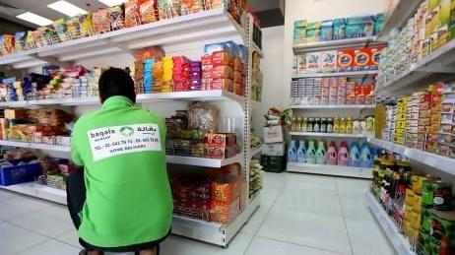
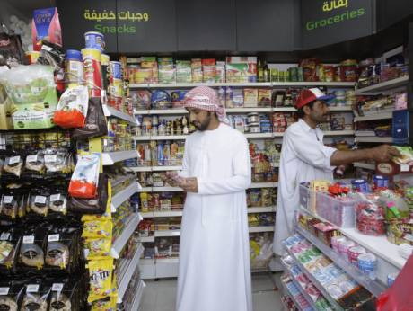
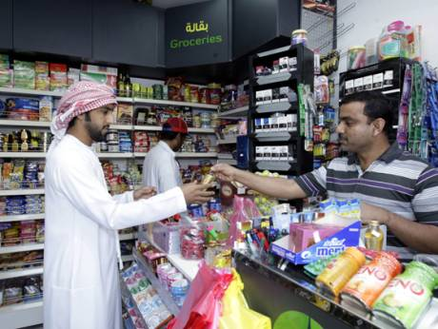
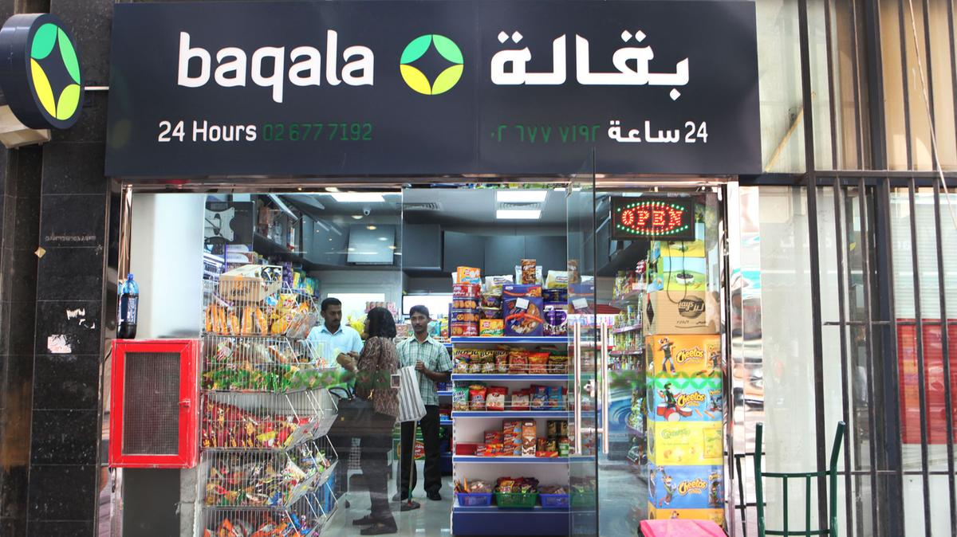

Reference
https://www.thenational.ae/uae/groceries-bill-of-up-to-dh200-000-to-meet-baqala-standards-1.314129
https://www.khaleejtimes.com/business/local/dubai-grocers-upbeat-on-ded-rules
https://www.thenational.ae/uae/health/end-of-an-era-as-abu-dhabi-s-old-style-groceries-shut-down-1.643532
Mohammad, R., & Sidaway, J. D. (2012). Spectacular urbanization amidst variegated geographies of globalization: Learning from Abu Dhabi's trajectory through the lives of South Asian men. International Journal of Urban and Regional Research, 36(3), 606-627.
. Khanna, P. (2010). Beyond city limits. Foreign Policy, (181), 120.
Elsheshtawy, Y. (2011). Informal Encounters: Mapping Abu Dhabi's Urban Public Spaces. Built environment, 37(1), 92-113.

